Olti Asllanaj

Spring 2017

Chapter 2 Project 1

**Project 1: Share Your travel photos**

**DIFFICULTY LEVEL: Beginner**

**overview**

This project is the first step in the creation of a travel photo sharing website. The page you are given is augmented by this project to add a Related Photos section to the page.

**Instructions**

1. Open **chapter02-project01.html** in the editor of your choice, so you can start making changes.

2. Open a browser and direct it to the same file (or double click the file in most operating systems). You should see a page like the top part of Figure 2.23 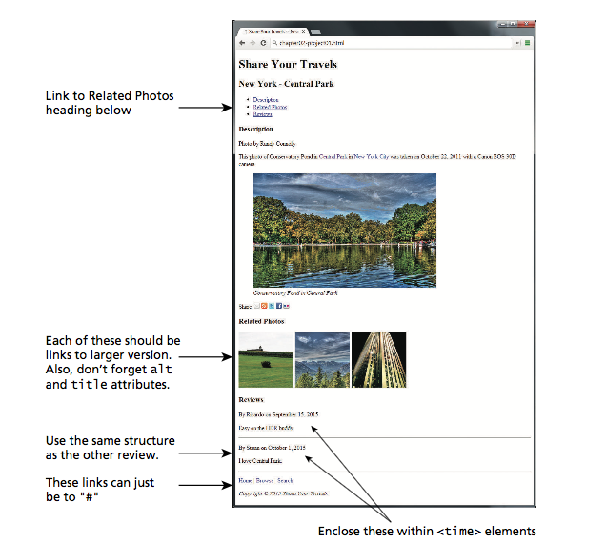

1. Start by adding a link to *Related Photos*, in the unordered list that currently contains *Descriptions* and *Reviews*. (You can make the href attribute point to # for the moment.)
2. Now go down to the bottom of the page and add the new Related Photos <section>.
3. In the new section add three images from the ones provided in the images folder. Use the small images **related-square1.jpg**, **related-square2.jpg**, and **related-square3.jpg** in the src of your <img> tag, but link to the large images with almost the same names.

**test**

1. Firstly, test your page by seeing if it looks like the one in Figure 2.23.
2. Now check that the link correctly links the Related Photos link to the newly  defined section, and that clicking on the related images brings up the larger  versions.
3. Validate the page by either using a built-in tool in your editor, or pasting the  HTML into **http://validator.w3.org/** and ensure that it displays the message: *This document was successfully checked as HTML5*!